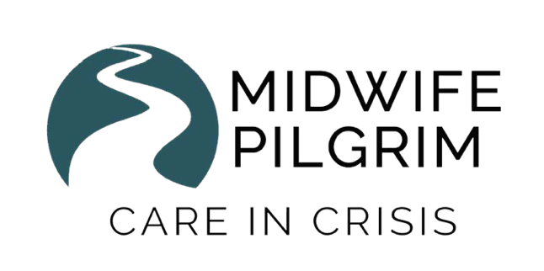

Helping Babies Survive (HBS)
Helping Mothers Survive (HMS BAB-C and PE&E)
Facilitator/Master Training

Dates: October 1-5, 2019
Location: Kansas City, KS
Number of participants: Minimum 4 - Maximum 6
Registration Deadline: September 1, 2019
CEUS: 5.4 ACNM CEUs (54 Continuing Education Hours) and 11 Pharmacology Hours for CNMs and CMs. CEUs/Continuing Education Hours are approved by NARM for CPMs as well as other RN and APRN accrediting organizations. CEUS are given for full and partial completion of workshops and for single workshops.

Cost: $750-$1350 sliding scale for full program
- All donations above the recommended amount of $1000 are tax deductible by law and will benefit Midwife Pilgrim’s work throughout the world.
- Please contact us for single workshop pricing.

Includes:
- Helping Babies Breathe (HBB) 2nd Edition, Essential Care for Every Baby (ECEB), Essential Care for Small Babies (ECSB) Facilitator trainings preparing you to train providers in low resource areas. We will also focus on Master Training – to teach how to teach teachers.
- Helping Mothers Survive (HMS) Bleeding after Birth- Complete (BAB-C) and Preeclampsia & Eclampsia (PE&E) Master Training preparing you to train providers in low resource areas as well as teach the teachers to ensure sustainability.
- Tea and snacks provided.

Not included:
- Equipment and supplies – it is recommended that every participant have the full HBS and HMS equipment prior to the course, however this is not required.

To register and for more information, contact: info@midwifepilgrim.org

